**Generative AI**

- Create new content, Powered by LLM Model that are pretrained on vast corpora of data.

**why Traditional ML models?**

1. Traditional ML models

- Libelled Data -> ML model -> Tasks (Text generation chatbots etc)

2. Foundation models

- Unlabelled data -> Foundation Model -> Tasks (Text generation chatbots etc)

**Use cases:**

Text, code, Image/video/3D

**Industry Use cases:**

Catboat, fraud detection, video game generation, autonomous vehicles, Chip Design, Optimize pricing and inventory,

Design renewable energy Sources optimized for Geo, Drug Development, improved medical imaging.

**Method to use Generative AI**

- Model Provider --> Entities who build foundation models from scratch themselves and provide them as a product to tuner and consumer.

- Model Consumer --> Fine Tune foundational models from providers to fit custom requirements.

Orchestrate the deployment of the model as a service for use by consumer.

- Application Developer --> Interact with Generative AI services form provider or tuner by text prompting or visual interface to complete desired actions.

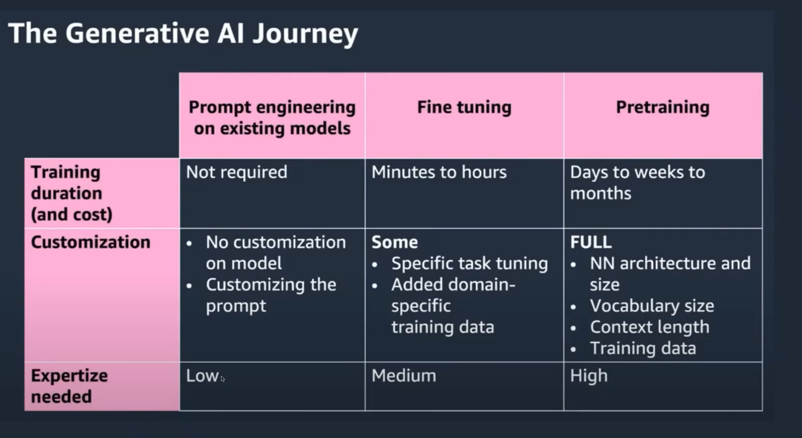

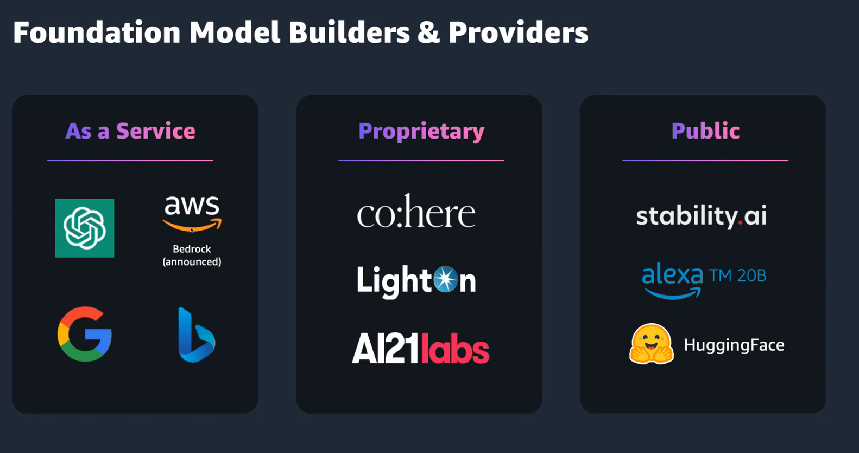

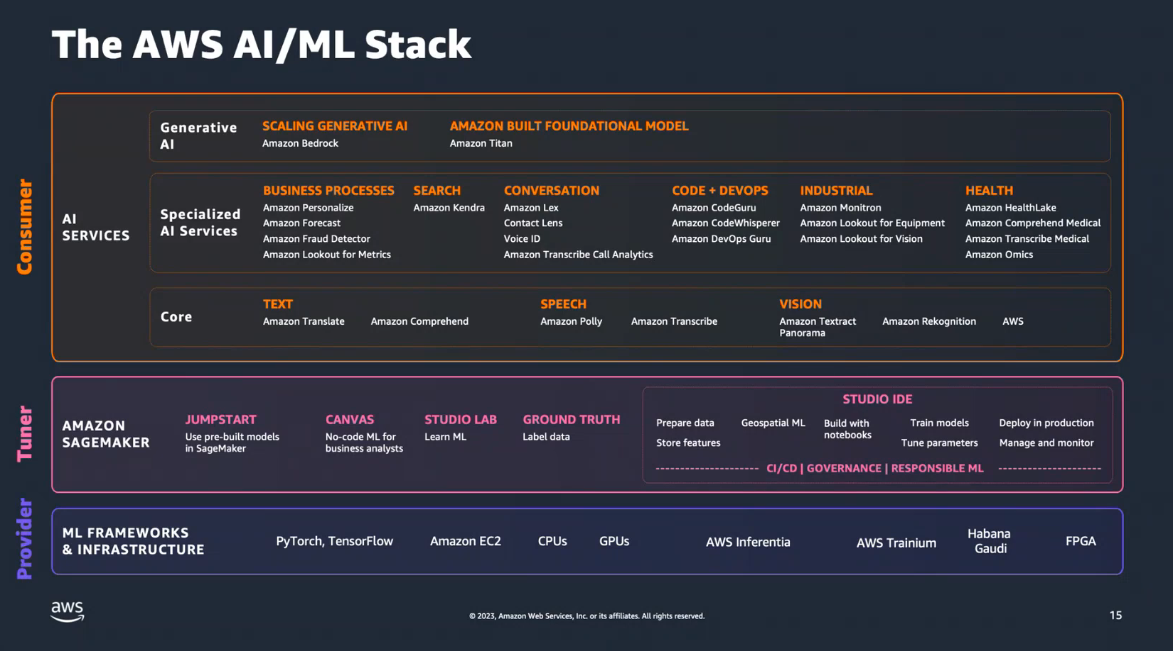

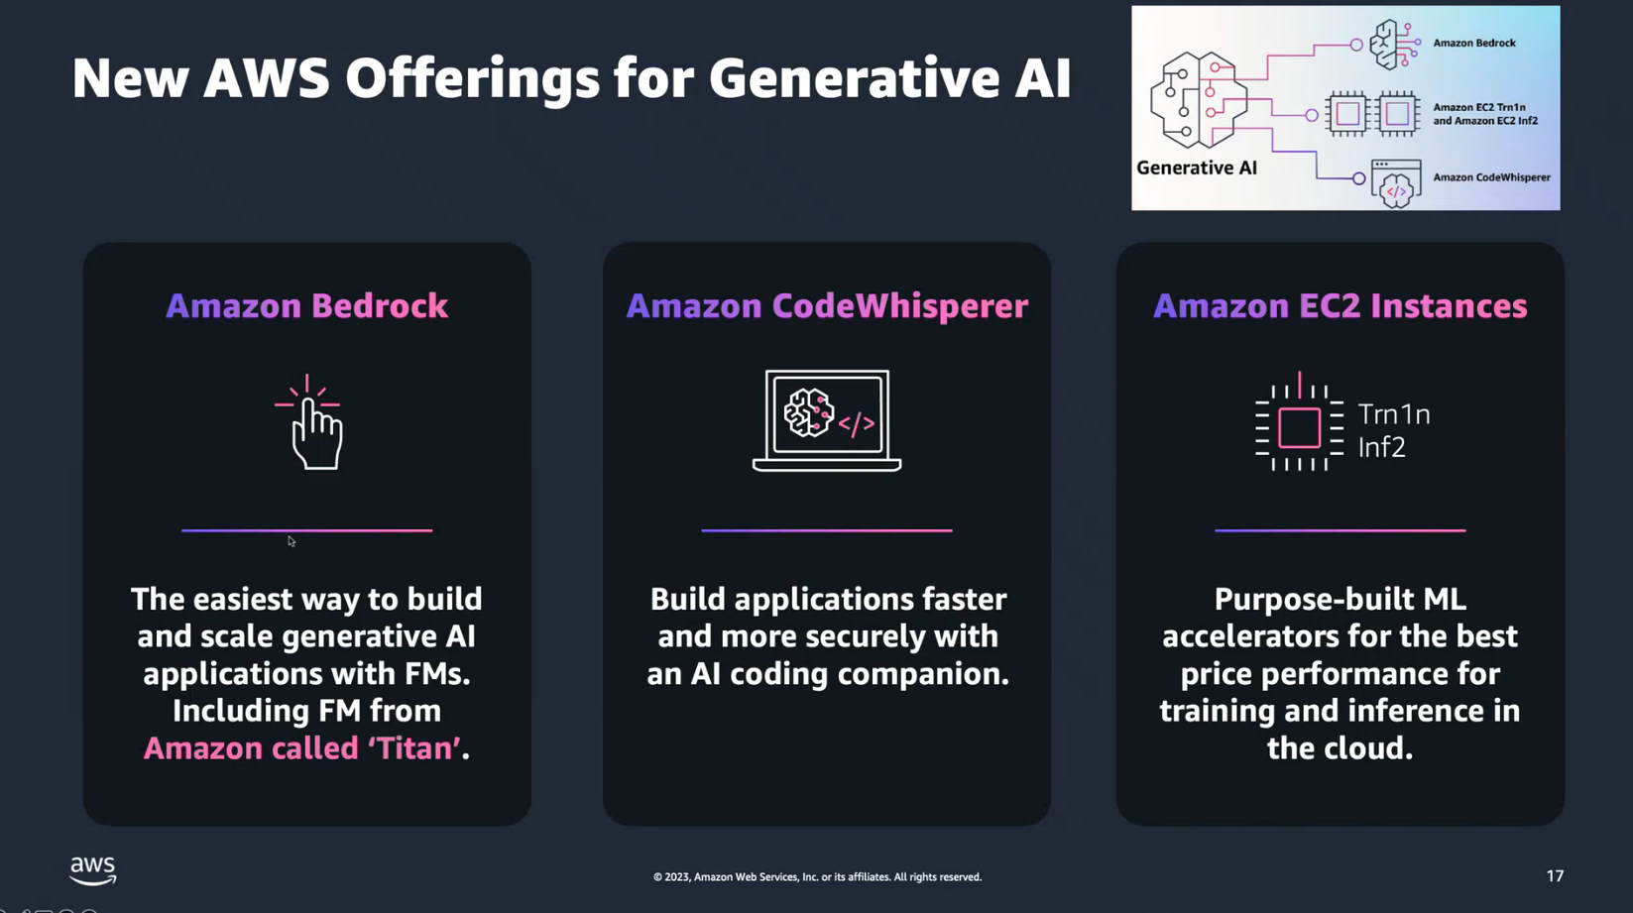

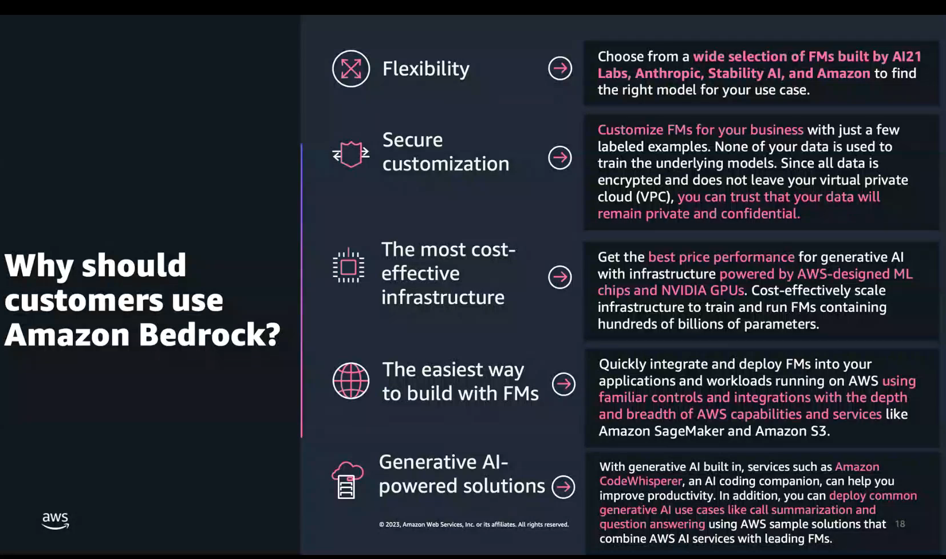

Why Should customers use Amazon Bedrock?

* Flexibility (Choose from wide selection of FMs build by AI21 Labs, Anthropic, Stability AI and Amazon to find the right model for use case.
* Secure customization
* The most cost-effective infrastructure
* The easiest way to build with FMs
* Generative AI- powered Solutions

**Bedrock**

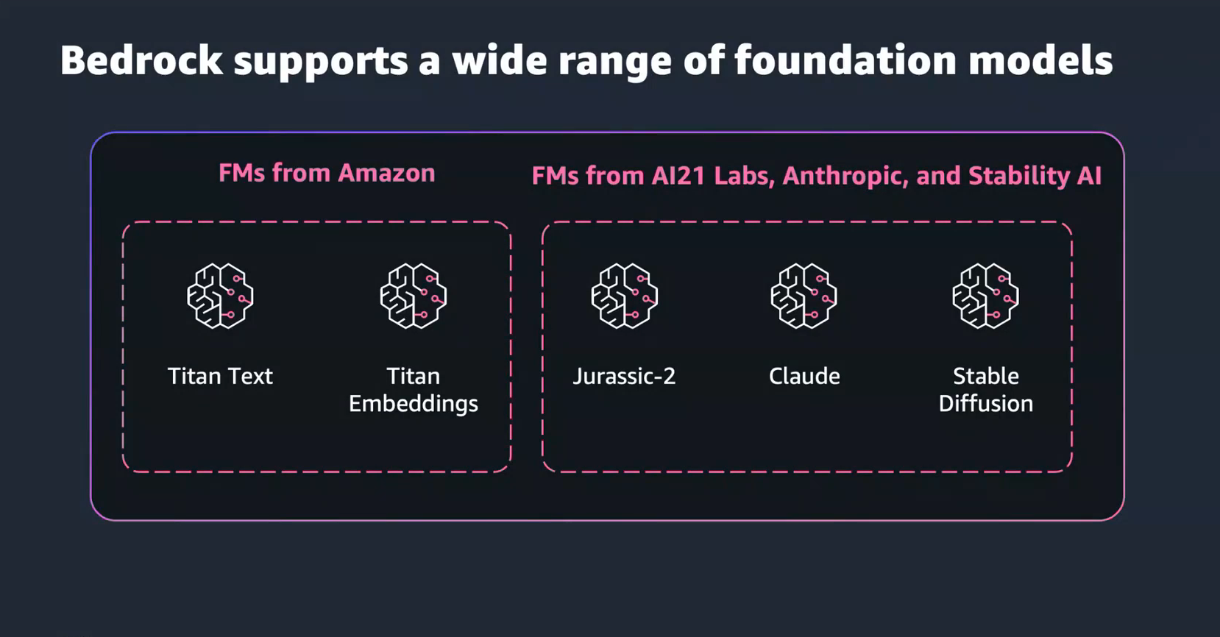

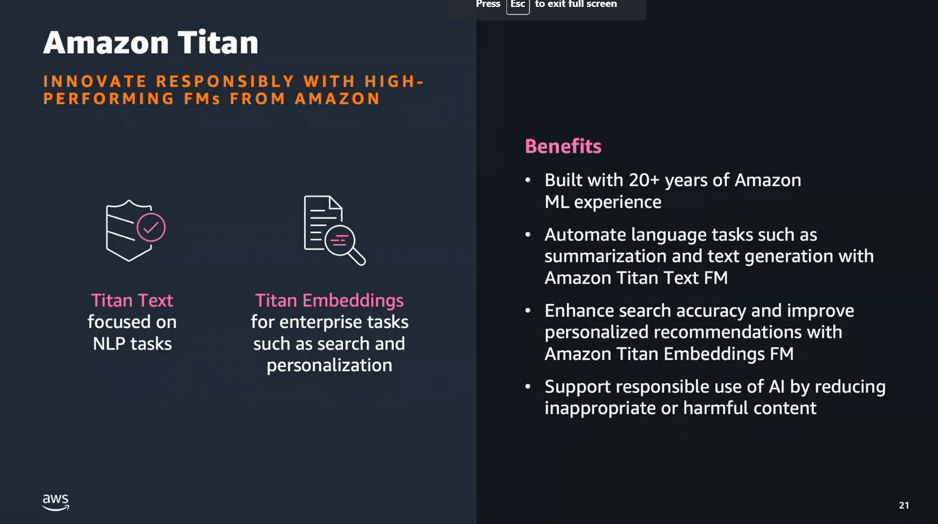

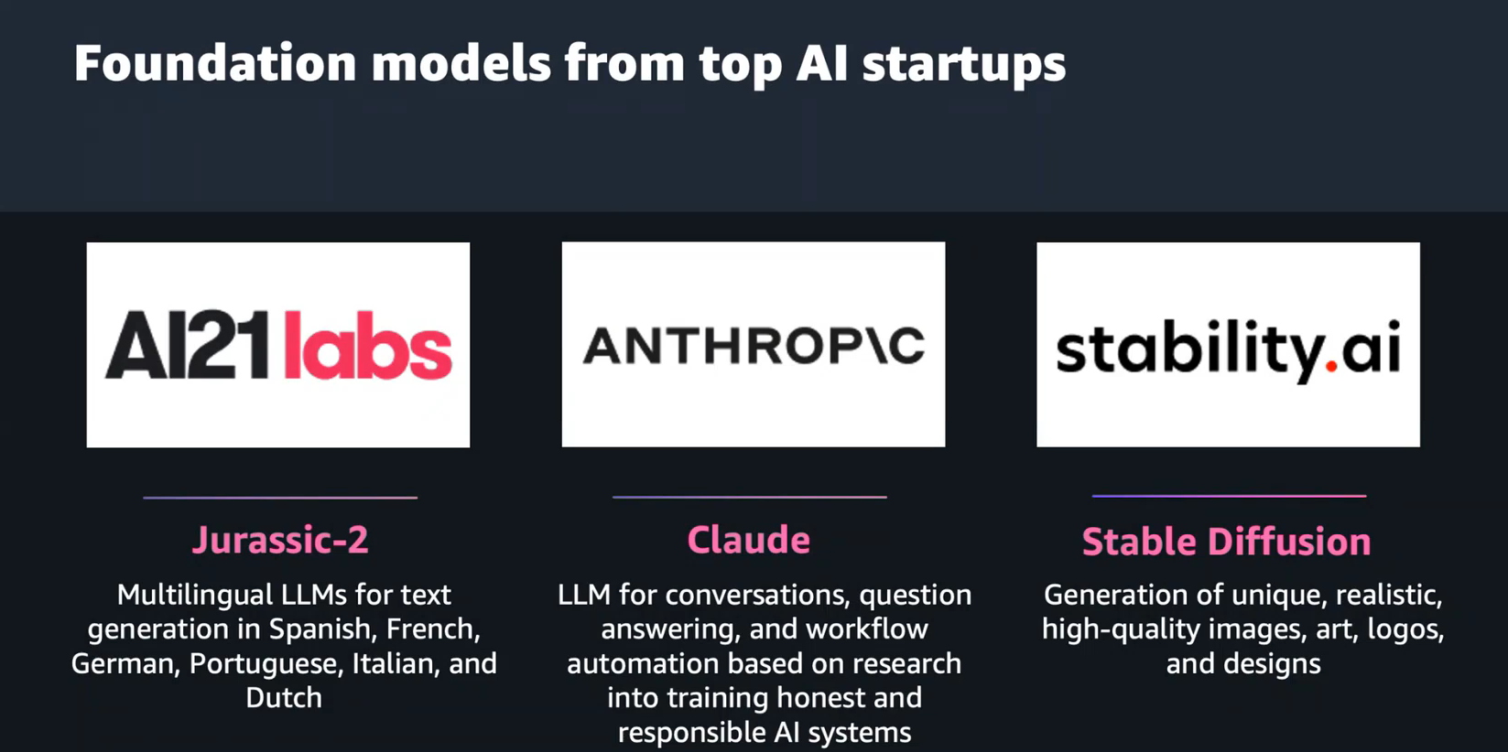

**SageMaker Jumpstart**

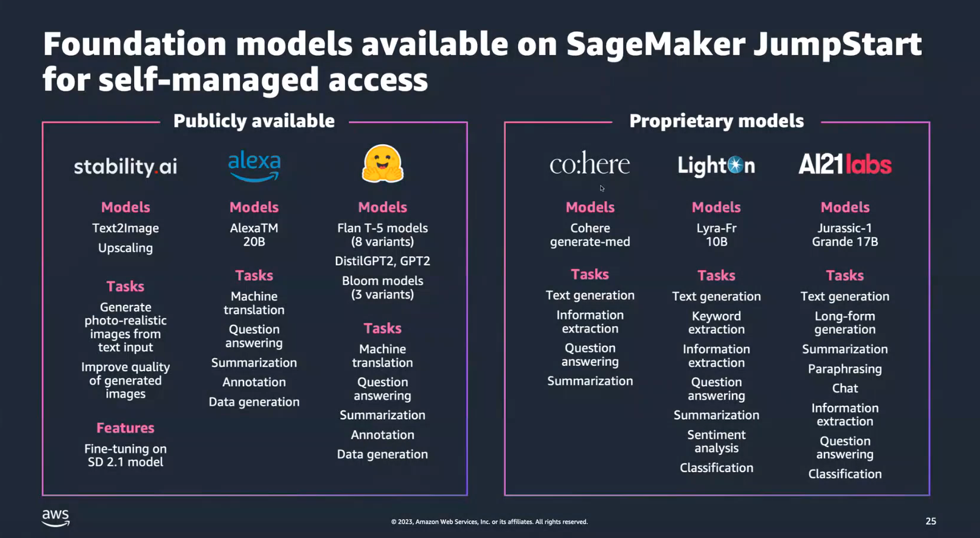

**Amazon Codewhispher**

Build Application faster and more securely with an AI coding Companion

